**Section 1 - Meta information**

Team: Erik, Einar, Lasse, Sondre

Sprint number: 2

Schedule: March 11th - March 31th

**Section 2 – Sprint planning note**

**2.1. Sprint goals**

Sprints 1 covered all aspects of the website content, and so the last step is to code it. Sprint 2s will involve creating the website using HTML, CSS, and potentially some Javascript.

**2.2. Definition of done**

The website is finished and working to a degree where we are able to ship it to the end users.

All of the content we planned is working on the website, on different devices and platforms.

**2.3. Sprint backlog items**

| **Item Id** | **Item description** | **Size Estimation** | **Customer value** |
| --- | --- | --- | --- |
| U01 | As a user I want to see the different types of amenities and facilities on the website | 8 | High |
| U02 | As a company or student, I want to find the pricing for the different membership plans and  an easy way to sign up for or cancel the services. | 20 | High |
| U03 | As a customer, it is very important to be able to access the website on different devices in an effective way. | 15 | Low |
| U04 | As a user, I want to know the contact information for the offices, to ask questions about the service. | 5 | High |
| U05 | As a user I want to find the location of the office with a map, and how to get there. | 5 | Medium |
| U06 | As a user I want to know how secure my information and data is with this company and how it is used | 8 | Medium |

**2.4. Kanban management board**

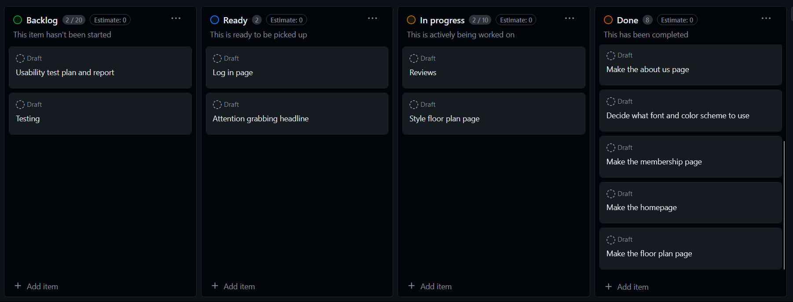

**Section 3 – Sprint Review note**

**3.1. Reflective summary**

Participants: Lasse, Erik, Einar, Sondre

Meeting duration, location: 1 hour, digital meeting

Summary:

We finished the third prototype which includes the four pages we wanted. These are the landing, membership, floorplan and about us pages.

Demonstration result: Four of the website pages are up and working

| **Item Id** | **Item description** | **Size Estimation** | **Status** | **Demo** |
| --- | --- | --- | --- | --- |
| U01 | As a user I want to see the different types of amenities and facilities on the website | 8 | High | Yes |
| U02 | As a company or student, I want to find the pricing for the different membership plans and  an easy way to sign up for or cancel the services. | 20 | High | Yes |
| U03 | As a customer, it is very important to be able to access the website on different devices in an effective way. | 15 | Low | Yes |
| U04 | As a user, I want to know the contact information for the offices, to ask questions about the service. | 5 | High | Yes |
| U05 | As a user I want to find the location of the office with a map, and how to get there. | 5 | Medium | No |
| U06 | As a user I want to know how secure my information and data is with this company and how it is used | 8 | Medium | No |

**3.2. Customer feedback**

Pros:

* Page layout was good and easy to read
* Straightforward navigation

Cons:

* Website not scalable to mobile view
* Pictures on floor plan were low res and have watermarks
* Lack of feedback when user registers/logs in
* Extra scroll bars on about us
* Register page too wide in comparison to login page
* Lack of locations. Need address and picture on map

**Section 4 - Retrospective meeting note**

Participants: Lasse, Erik, Einar, Sondre

Meeting duration, location: 1 hour, digital meeting

* Start doing:
  + More meetings, staying ahead of schedule - we ended up doing everything last minute and rushing
  + Use own branches instead of everyone working on main branch
* Stop doing:
  + Committing directly to the main branch: This causes merge conflicts which use up time
  + Getting sidetracked: This wastes time, and we should rather take breaks to do this
  + Overlooking mobile development: Not all pages work in mobile format
* Continue doing
  + Helping each other and collaborating to find solutions
  + Working together to make decisions that affect all pages